SensesWA wants you to know that you can get help from an Advocate if you need it. We explain how to do this below.
Easy Read: Getting help from an Advocate

An advocate is someone you can trust and who is on your side.
- They can help you to tell people what you want.
- They can help you to tell people what you need.
- They can help you to tell people when something is wrong.

Everyone can have an advocate to help them.

- An advocate can be a family member.
- An advocate can be a friend you know well.
- An advocate can be a support person you know well.
An advocate can be a professional advocate.
A professional advocate is paid to be an advocate for their job.

An advocate can help you make decisions.
An advocate can help you understand information.

An advocate can help you say what you want.
An advocate can help you get the services you need.
An advocate can help you know about your rights

Rights are:
- Things we can all have
- Things we can all feel
- Things we can all get
- Things we can all do

We all have rights. We all have equal rights.
This means we all have the same rights.
This means we can all expect to be treated fairly.

An advocate can help you if you are not treated fairly.

An advocate can help you if you experience discrimination.
Discrimination is when one person does not treat another person the same as everyone else.
Discrimination is when one person is treated unfairly by another person.

An advocate can help you make a complaint.

An advocate can help you write a letter or email or make a phone call about what happened.

An advocate can help you in a meeting to talk about the problem.

An advocate can help you get advice on legal problems.

You have the right to ask for help from an advocate if you want that.

If you need one, there are professional advocates working at these places who will try to help you fix the problem.

You or someone you trust, can call to speak to an advocate:
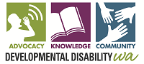
Developmental Disability WA
9420 7203
City West Lotteries House
2 Delhi Street, West Perth
https://ddwa.org.au/
Ethnic Disability Advocacy Centre
9388 7455
320 Rokeby Road Subiaco
http://www.edac.org.au/

Explorability Inc
6361 6001
1/9 Parkes St
Cockburn Central
https://www.explorability.org.au/
Sussex Street
6253 9500 - 29 Sussex St East Victoria Park
0447253516 - 114 Sanford St Geraldton
http://www.sscls.asn.au/
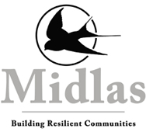
Midlas
9250 2123
23 Old Great Northern Hwy
Midland
Personal Advocacy Service
9275 5388
28 Holdhurst Way Morley

People With disabilities WA
9420 7279
City West Lotteries House
2 Delhi Street, West Perth
https://www.pwdwa.org/
Your Say Uniting Care West
1300 663298
10/15 Aberdeen St, Perth

Citizen Advocacy Perth West
9445 9991
2A/ 28 Guthrie Street
Osborne Park

Advocate for Children in Care
189 Royal Street, East Perth WA 6004
9222 2518

Ombudsman Western Australia
08 9220 7555
PO Box Z5386
St Georges Terrace
PERTH WA 6831
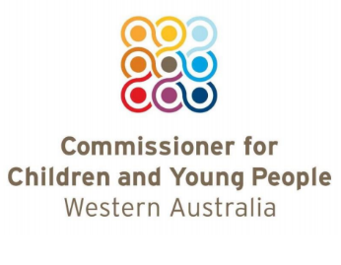
Commissioner of Children and Young People
(08) 6213 2297
Ground Floor, 1 Alvan Street, Subiaco WA 6008

Foster Carer Association of WA
Level 1, 20 Gibberd Road, Balcatta WA 6021
(08) 9242 4222

Regions - Outside Perth:
9721 6444
4 Plaza Street
South Bunbury
https://advocacywa.org.au/

